Dear Mr. Higgins,

You persistence would find a better use if you did put some effort to performing your self-proclaimed Internet sleuth role. We, on our part, would like to note that the Ministry of Defense of the Russian Federation has already provided perfectly detailed and clear examples of your falsifications. While we completely agree with the points made by our colleagues, we would like to add a few more facts.
It is obvious for anyone that your priority is creating an impression among the public that Russian troops were present at an alleged launch site of the missile that hit the Malaysian plane on July 17, 2014 in the skies over Ukraine. However, you have failed to confirm this. As of today, no one has provided actual proof of Russian Armed Forces' presence in Ukraine. This is simply impossible because there are no Russian troops there, and there never were. The social network data as well as different Internet posts that you use cannot, under any circumstances, be taken as actual proof of Russia's involvement in the conflict in Ukraine.
Now let's see the specific examples. It should be noted that your falsifications are the most visible in your tendency to pass edited images as originals that allegedly are keys to the truth.
Let's, for instance, consider your report published on October 8 2015, where you claim to have summed up the open source investigation on MH17. In particular, you allegedly determine the origin of the Buk missile launcher that shot down the Malaysian plane, its movement and even its escort. All your conclusions are accompanied by photos. Well, you asked for facts proving falsification on your part. Let us point out several of them.
- Using this collage of photos and video screenshots showing Volvo low-loader cabins on pages 1 and 8 of your report, you are trying to prove this is the same vehicle that allegedly brought the missile launcher from Russia to Ukraine on July 17, 2014, and back to Russia on July 18. This is a fake. Even if we leave out the important point that the Internet does not allow to "precisely" determine the date and route of a vehicle's movement, it is clear that the photos show different vehicles. The quality of the images is artificially reduced to obscure this, but it is clear that the first photo shows a spare tire while the others don't (apparently the spare tire just disappears and then pops up again). Apart from that, the technical features of the cabins clearly show these are indeed different vehicles.
p. 1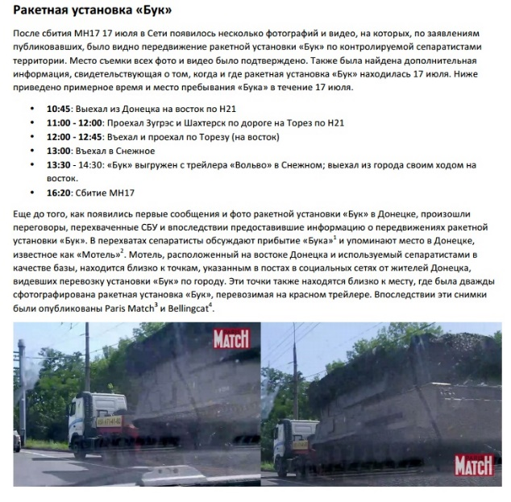p. 8 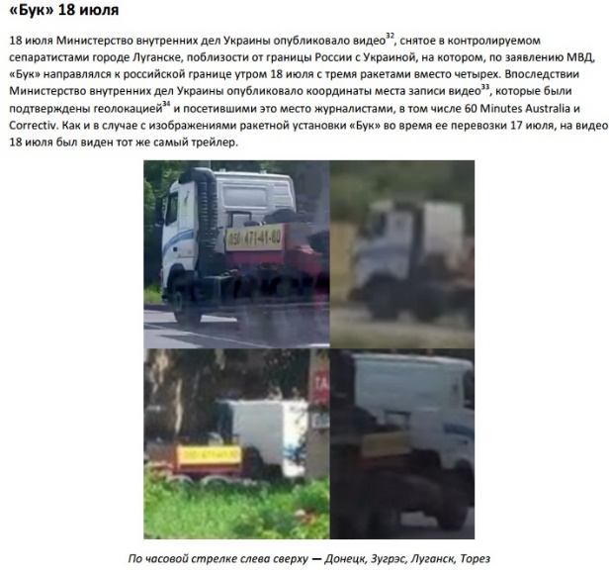

- Another example. You claim that while examining photos and videos of Buk missile launchers in Ukraine and Russia, you found out that a Buk missile launcher spotted in Russia in late June 2014 had features matching the one seen in the two photos of a Buk missile launcher in Donetsk. The Buk spotted in Russia was allegedly marked as "3x2", the "x" meaning a poorly readable number on the vehicle's side, which, according to your unsubstantiated opinion, is characteristic of side numbers of various vehicles transported from Russia to Ukraine. This is also a fake. In fact, the "3x2" side number tells us that the vehicle could belong to any anti-air missile brigade, Ukrainian notwithstanding. A side number "3x2" denotes: 3 - battalion, x - battery, 2 - the number of the launcher in a battery. Such three-digit numbering of military vehicles has been preserved back from the Soviet era and is used in almost all armies of the ex-USSR republics, including the Ukrainian army.
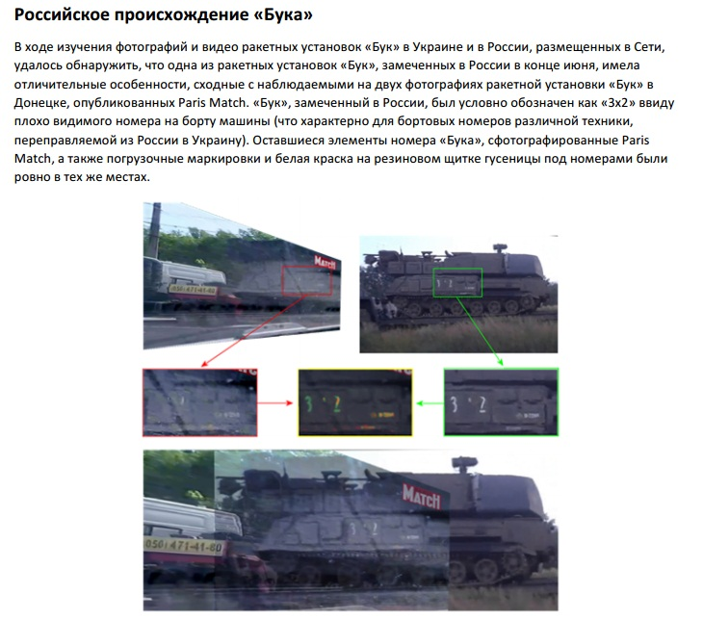

- Let us point out another fake of yours. You've repeatedly presented a "bombshell" photo of allegedly a smoke trail of a missile launch, hinting at a location near Snizhne. The photo in question shows a vertical smoke column. Any military expert would tell you that a Buk missile's trail cannot be vertical. All laws of physics dictate it would appear at an angle. It is easy to find videos on the Internet showing missile launches at exercises. Your "bombshell photo" can not possibly be related to a Buk missile launch.

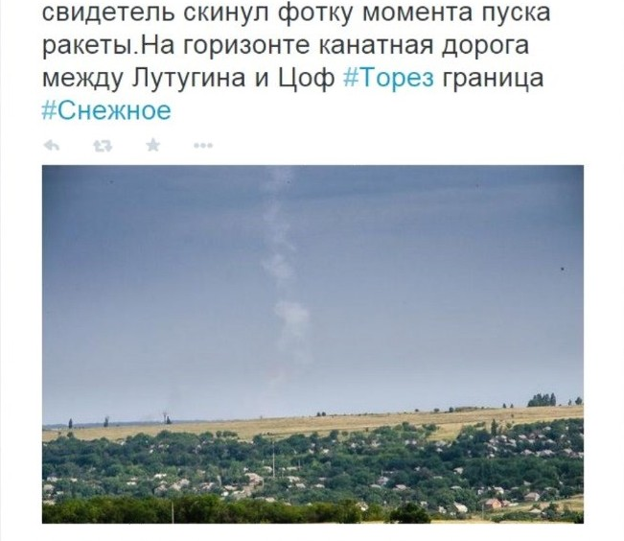
- There is something else. To hammer in your point, in your report you show a missile and tell your readers it is a Buk missile, probably as a way to show off. But even this is a falsification: what we see is a Kub missile which has been retired and is not used by the Russian army.
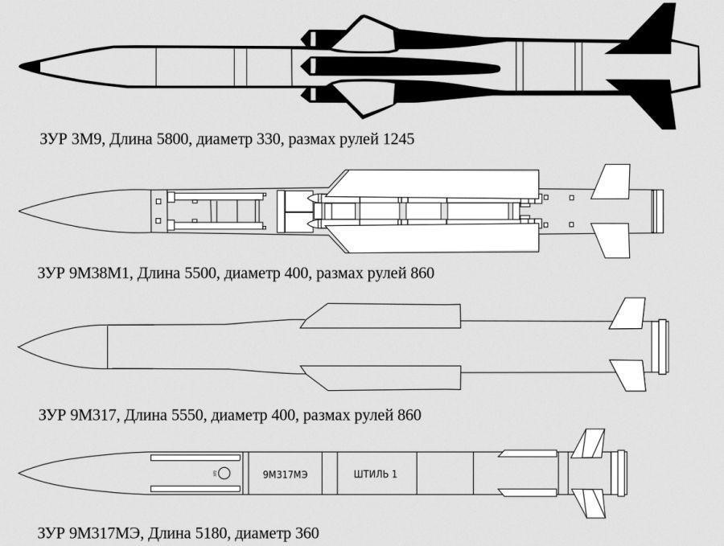

And that's only from your October report.
One can also recall the report you authored in May 2015, called "Forensic Analysis of Satellite Images Released by the Russian Ministry of Defense at an International Press-Conference on July 21, 2014". In that report you claimed that at least two of the six Russian MoD satellite images were falsified. In order to check their validity, you used "source analysis, metadata analysis and error level analysis" - a technique of N. Kravetz, a professor of Texas and California universities. On the same day, Mr. Kravetz himself dismissed your analysis on his Twitter, saying that this is an excellent example "how not to do analysis" and calling the report "reading tea leaves". Imagery analysis expert and founder of IRISPIX photo archive J. Kriese lambasted the Bellingcat technique, calling it "unscientific". Sorry, buy yet again, this is a falsification.
Just like your February 2016 opus, peppered with Russian military unit names and soldiers' last names. The main culprits, you claim, are Vladimir Putin and Sergey Shoigu. The proof your present is dozens of photos taken from social networks showing some soldiers with blurry faces and military vehicles with poorly visible side numbers in unknown locations. This is ridiculous.
We could go on listing specific examples of your fakes. But we'd prefer to specifically address the following point. One of the main principles used by journalists and anyone related to the information space is being sure the material they use (which will be republished by all kinds of media) is verified. We are sure you know better than anyone how easily modern technology allows to create and disseminate any myth which would seem quite true at a first glance.
We hope you realize how important is the quality of information related to such tragic events. This is why we call on you to refrain in future from blatant falsifications and provide only verified, sound information - if nothing else, because the topic you work on is very sensitive and directly relates to people who have experienced a horrific loss of their loved ones.
If you want and intend to do serious investigation, we are ready to answer your questions and provide the information you require. However, if you will continue to adhere to your tactics of cherry-picking content, then we believe future correspondence makes no sense. We would prefer that you take the first option.

Kind regards,
Information and Press Department of the Ministry of Foreign Affairs of the Russian Federation.

